DOCX-to-PDF Rendering Tests
Rex Jaeschke (rex@RexJaeschke.com)
2013-02-21

Part 1, §20.1.8.40, “innerShdw (Inner Shadow Effect)”, p. 2862
This element specifies an inner shadow effect. A shadow is applied within the edges of the object according to the parameters given by the attributes.
Inner Shadow
Part 1, §20.1.8.45, “outerShdw (Outer Shadow Effect)”, p. 2864
This element specifies an Outer Shadow Effect.
[Example: The following is an example of an outer shadow effect.
Outer Shadow
end example]
Part 1, §20.1.8.50, “reflection (Reflection Effect)”, p. 2868
This element specifies a reflection effect.
[Example:
end example]
Reflection Effect
Part 1, §20.4.2.6, “effectExtent (Object Extents Including Effects)”, pp. 3100–3103
[Example: Consider the following DrawingML image:
This object has no effects, and hence would have the following effect extents:
<wp:effectExtents b="0" t="0" l="0" r="0" />
However, if a shadow effect was applied which added effects to the right of the image:
Then the additional extent the right side would be specified in the r attribute on this element:
<wp:effectExtents b="0" t="0" l="0" r="695325" />
The r attribute has a value of 695325, specifying that that 695325 EMUs must be added to the right side of the image. end example]
Attributes | Description
b (Additional Extent on Bottom Edge) | Specifies the additional length, in EMUs, which shall be added to the bottom edge of the DrawingML object to determine its actual bottom edge including effects.  [Example: Consider the following DrawingML image:  This image has an effect on all four sides, resulting in the following markup:  <wp:effectExtent l="504825" t="447675" r="771525" b="809625" />  The b attribute value of 809625 specifies that 809625 additional EMUs must be added to the bottom of the image to compensate for the effects on the image. end example]
l (Additional Extent on Left Edge) | Specifies the additional length, in EMUs, which shall be added to the bottom edge of the DrawingML object to determine its actual bottom edge including effects.  [Example: Consider the following DrawingML image:  This image has an effect on all four sides, resulting in the following markup:  <wp:effectExtent l="504825" t="447675" r="771525" b="809625" />  The l attribute value of 504825 specifies that 504825 additional EMUs must be added to the bottom of the image to compensate for the effects on the image. end example]
r (Additional Extent on Right Edge) | Specifies the additional length, in EMUs, which shall be added to the bottom edge of the DrawingML object to determine its actual bottom edge including effects.  [Example: Consider the following DrawingML image:  This image has an effect on all four sides, resulting in the following markup:  <wp:effectExtent l="504825" t="447675" r="771525" b="809625" />  The r attribute value of 771525 specifies that 771525 additional EMUs must be added to the bottom of the image to compensate for the effects on the image. end example]
t (Additional Extent on Top Edge) | Specifies the additional length, in EMUs, which shall be added to the bottom edge of the DrawingML object to determine its actual bottom edge including effects.  [Example: Consider the following DrawingML image:  This image has an effect on all four sides, resulting in the following markup:  <wp:effectExtent l="504825" t="447675" r="771525" b="809625" />

Part 1, §20.4.2.18, “wrapThrough (Through Wrapping)”, pp. 3118–3119
[Example: Consider an object with the following wrap points:
If this object uses tight wrapping, then text cannot be placed within the maximum left and right extents of the wrap polygon at any location:

However, with through wrapping:
end example]
Part 1, §20.4.2.19, “wrapTight (Tight Wrapping)”, pp. 3121–3122
[Example: Consider an object with the following wrap points:
If this object uses tight wrapping, then text cannot be placed within the maximum left and right extents of the wrap polygon at any location:
However, with through wrapping:
end example]
Part 1, §L.4.3.2.10, “Effect Style List”, p. 4801
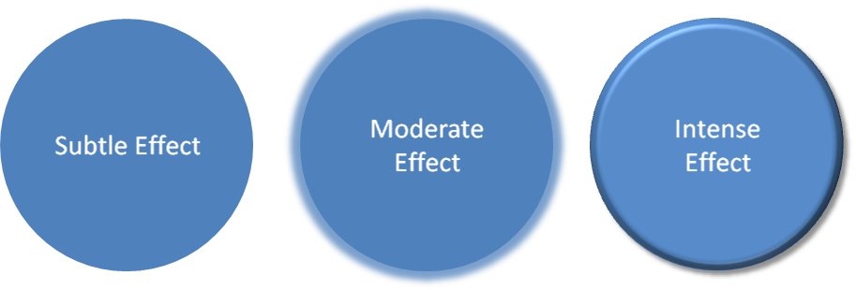
Figure 1: Subtle, moderate, and intense effects applied to a shape that has a blue fill.
Part 1, §L.4.3.2.13, “Table Styles”, p. 4801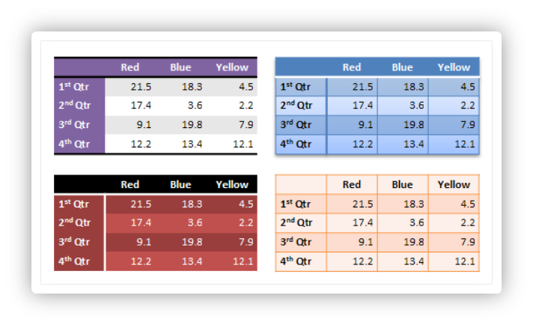
Figure 2: Different table styles in use.
Part 1, §L.4.5.2, “This aspect of DrawingML …”, p. 4820
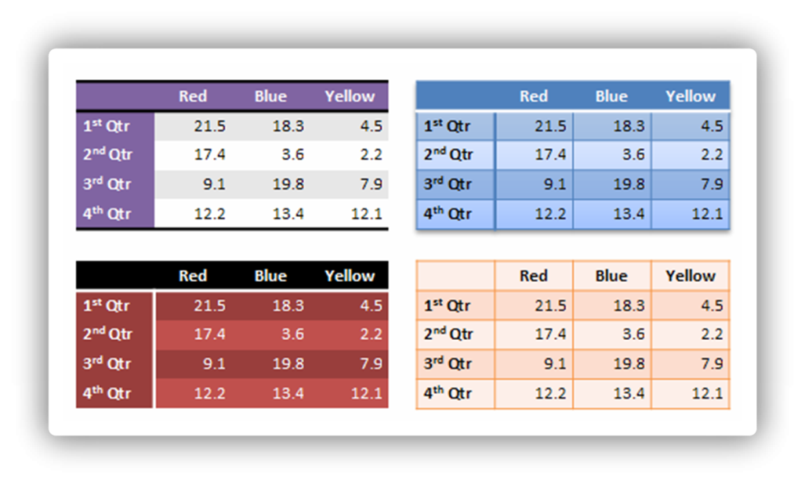
Figure 3: Different table styles in use.
Part 1, §L.4.8.5.3, “Line Join Properties”, p. 4867
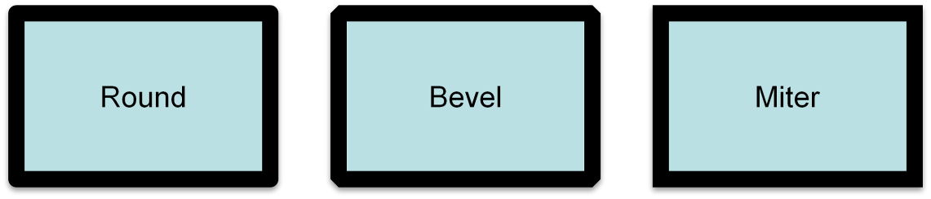
Part 1, §L.4.8.5.4, “Head/Tail End Properties”, p. 4867
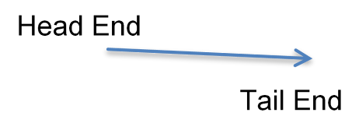
Part 1, §L.4.8.5.5, “Line Attributes”, p. 4868
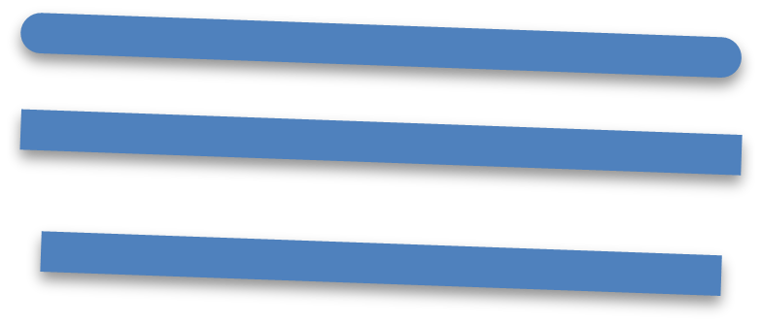
Part 1, §L.4.8.6.4, “Outer Shadow”, p. 4870
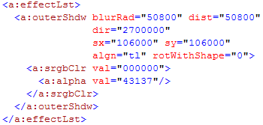
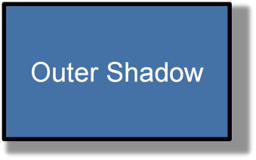
Outer shadows contain a color choice as well as several attributes:
Part 1, §L.4.8.6.6, “Reflection Effects”, p. 4871
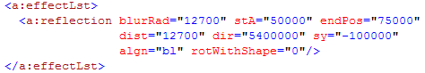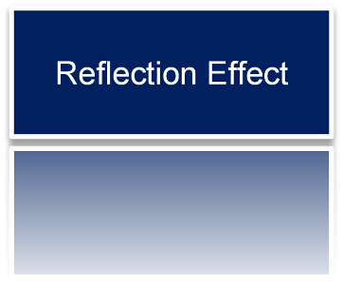
Reflections are represented entirely through attributes:

Part 1, §L.4.8.6.7, “Soft Edge Effects”, p. 4872
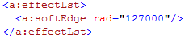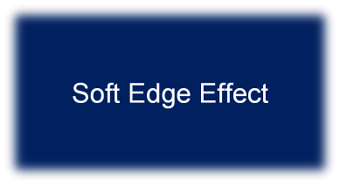
Part 1, §L.4.15.3, “Data Model”, p. 4912
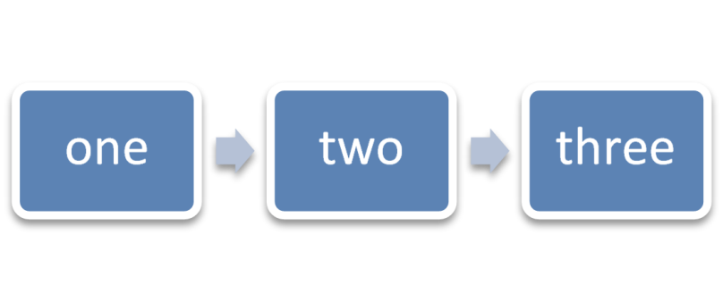
Figure 4: Example diagram with data.
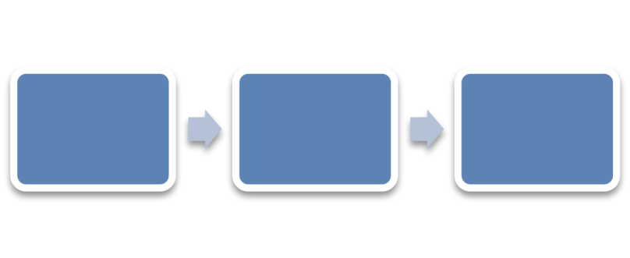
Figure 5: An empty diagram in its initial state.
Part 1, §L.6.2, “Metadata”, p. 4912

