DOCX-to-PDF Rendering Tests

Rex Jaeschke ([rex@RexJaeschke.com](mailto:rex@RexJaeschke.com))

2013-07-29

**Part 1, §17.7.2, “Style Hierarchy”, p. 609**

…

The following table illustrates the order of application of these defaults, and which properties are impacted by each:

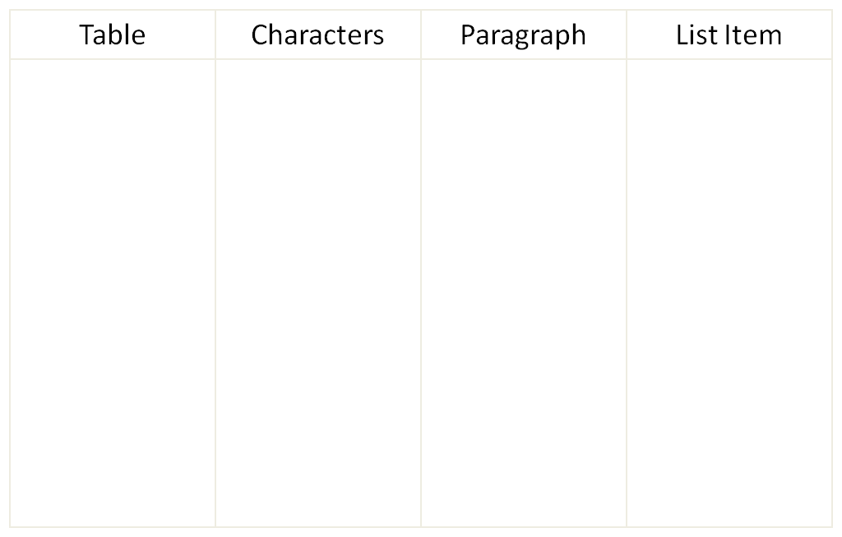

Application order

Document Defaults

Table

Paragraph

Numbering

Character

Direct Formatting

This process can be described as follows:

…

**Part 1, §17.7.3, “Toggle Properties”, p. 611**

**Document Defaults**

false

**Table**

false 🡨 true

**Paragraph**

true 🡨 none 🡨 none

**Character**

none

false

true

true

false

XOR

false

OR

false

🡨 symbolizes the traversal of a basedOn reference

*end example*]

**Part 1, §L.1.5.8, “Complex Table Example”, p. 4543**

…

As shown above, table cells can be merged horizontally. This is represented with a single table cell whose gridSpan property defines the number of grid units consumed by that table cell for the current row. Consider the following fixed width table, which makes extensive use of resized and merged cells on what is actually just a seven-column grid. (The arrows point to each (invisible) vertical line of the grid and the numbers refer to the grid columns):

|  |  |  |  |  |  |
| --- | --- | --- | --- | --- | --- |
|  | | | |  | |
|  | |  | |
|  |

1 2 3 4 5 6 7

Although the table is visually complex, the standard rules apply: the first cell in the table is simply a cell which spans four grid units horizontally, as specified in the gridSpan element, and whose preferred with is 2952 twips, specified in the tcW element:

…

**Part 1, §L.2.6.3, “File Architecture”, p. 4658**

Inside the file, the comment content ("Comments1") is expressed separately from the sheet information ("Sheet1"), and separately from the drawing information ("legacyDrawing1") for the containing object:

The parts are related using relationships from the sheet to the comments and drawings parts. Comments are stored together at the sheet-level. Therefore, if there are five worksheets in a workbook, and three of those contain cells with associated comments, then there are three comment parts in the file, one for each sheet.

…

**Part 1, §L.4.4.3.1, “Setting Up the Text Area”, p. 4814**

…

When looking at the flow it is useful to discuss the potential for *overflow*. That is, the text must flow outside the text area because it is too large to fit inside. For this, there are two common overflow types: vertical and horizontal. The vertical overflow can be handled in three ways:

* overflow: This allows the text to flow outside the text area.

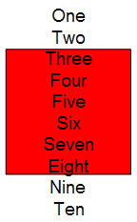

* ellipsis: This crops the text that overflows and adds "…" to denote that there is hidden text.

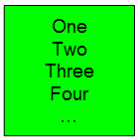

* clip: This crops the text just as ellipsis but does not insert "…", so the user has no indication that there is hidden text.

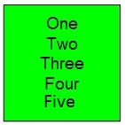

* Horizontal overflow works exactly like vertical, but with only two options: overflow and clip, which both operate as described above.

**Part 1, §L.4.4.3.7, “Adding Bullets”, pp. 4816–4817]**

Bullets are specified per paragraph, so bullets can be mixed and matched within a single text body to appear as a coherent text group. The types of bullets available are:

* Character Bullets: Uses a font character to denote a bullet and can be set to appear in any size (percentage of text), color (all available including theme colors), and font. *The properties are Bullet Color, Bullet Size, Bullet Font Typeface, Bullet Character (represents the actual bullet)*

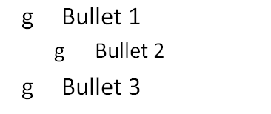

* Auto-Numbered Bullets: Uses the application logic to assign a series of numbers/characters to a specific bulleted item using just a bullet scheme and a starting number. (When a starting number is used, all bulleted paragraphs listed after the start number are automatically numbered based on this last known start number. The scope of this auto-numbering is only within its current text body, no start at number would ever carry over to a different text body.) The properties are Start At number, Bullet Scheme (letters, roman numerals, etc.), Bullet Color, Bullet Size, and Bullet Font Typeface.

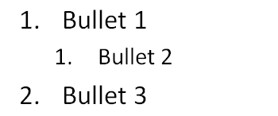

* Blip Bullets: Uses a picture to denote a bulleted item. The only additional property available with this type of applied bullet is the size (percentage of text). If the graphic is not in the applications standard set of graphics then the attached graphic is converted to a PNG format, placed in the document container and is given a relationship id that is used later to reference the image. The properties are Embed id (corresponds to a bullet graphic) and Bullet Size.

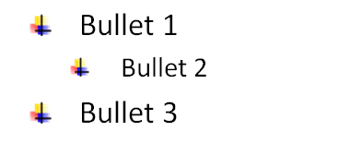

**Part 1, §L.4.7.4.1, “Scaling and Translating a Group”, p. 4845**

…

**Part 1, §L.4.8.4.2, “Gradient Fills”, p. 4861**

…

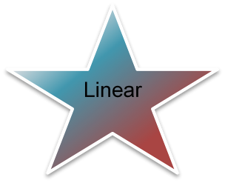

**Part 1, §L.4.11.2, Text Wrapping”, p9. 4888–4889**

… Through Wrapping - In this type of text wrapping, a wrapping polygon is created just like with tight wrapping, but any indents in the wrap polygon can be filled with text in this case.  
  
If the wrapping polygon looks like the following:   
  
Tight wrapping would look like this:   
  
While through wrapping would look like this:   
  
In the latter case, notice that text fills in the 'indentation' within the wrapping polygon. …