18.8.1 alignment (Alignment)
…
textRotation (Text Rotation) | Text rotation in cells. Expressed in degrees. Values shall be either in the range 0 to 180, or the single value 255.  For 0 - 90, the value represents degrees above horizon. For 91-180 the degrees below the horizon is calculated as:  [degrees below horizon] = 90 - textRotation. The first letter of the text is considered the center-point of the arc.  For 255, the value does not represent an angle and instead denotes that the text should be written one character beneath another, without any rotation.  0  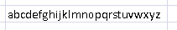  45  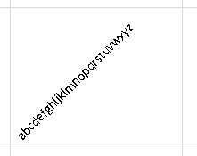  90  135  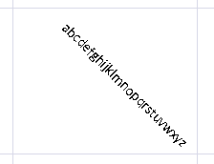  180  255  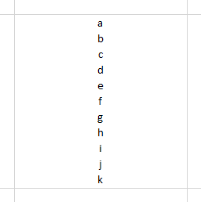  The possible values for this attribute are defined by the W3C XML Schema unsignedInt datatype.

…

