When looking at the flow it is useful to discuss the potential for overflow. That is, the text must flow outside the text area because it is too large to fit inside. For this, there are two common overflow types: vertical and horizontal. The vertical overflow can be handled in three ways:
- overflow: This allows the text to flow outside the text area.
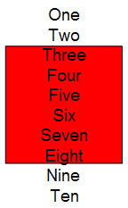
- ellipsis: This crops the text that overflows and adds "…" to denote that there is hidden text.
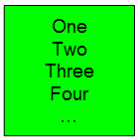
- clip: This crops the text just as ellipsis but does not insert "…", so the user has no indication that there is hidden text.
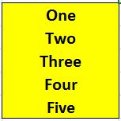
Horizontal overflow works exactly like vertical, but with only two options: overflow and clip, which both operate as described above.

