DR 16-0020 — WML: Improved example for sz element

Status: Open

Subject: WML: Improved example for sz element

Qualifier: Request for clarification

Submitter: WG4 Organization: WG4

Contact Information: Click here to enter text.

Submitter’s Defect Number: None

Supporting Document(s): None

Date Circulated by Secretariat: 2016-09-27

Deadline for Response from Editor: 2016-11-27

IS 29500 Reference(s): 29500-1:2016 DIS, Part 1: §17.15.2.39 sz, “(Frame Size)”; Part 1: §17.15.2.40 sz, “(Nested Frameset Size)”

Related DR(s): None

Nature of the Defect:

The two issues regarding sz were spun off from DR 16-0010 “WML: Confusing example used repeatedly in Descriptions of attribute w:val” and put into this new DR.

The changes suggested below were proposed as part of the resolution to DR 16-0010.

From Francis: I think that the text of the val attribute description is basically OK, but the clause as a whole would benefit from a clearer example above the attribute table. The interpretation of sz depends upon the element frameLayout in the same parent frameset element, but the example doesn't show frameLayout, which must contain val="rows" for the example to make sense.

Solution Proposed by the Submitter:

None

Schema Change(s) Needed:

No

**Editor’s Response:**

**Part 1: §17.15.2.39 sz, “(Frame Size)”, p. xx**

This element specifies the size for a single frame within a frameset.

This size shall be interpreted based on the contents of the frameLayout element (§17.15.2.17) for the parent frameset, as follows:

* If the val attribute on that element is cols, then this element specifies the width of the frame
* If the val attribute on that element is rows, then this element specifies the height of the frame

Once the axis of this measurement has been established using the criteria above, the actual value of the measurement shall be determined by the following:

* If the val attribute ends in an asterisk (*), then this measurement is a relative measurement (relative to all other frames in this frameset).
* If the val attribute ends in a percentage symbol (%), then this measurement is a percentage of the height and/or width of the parent window, respectively.
* Otherwise, the value of the val attribute specifies the size of the frame in pixels. This measurement shall be interpreted in the context of the pixelsPerInch element (§17.15.2.34) to determine the width of the resulting measurement in inches.

If this element is omitted, then no information shall be implied about the size of the current frame.

[Example: Consider a frameset consisting of the following three frames:

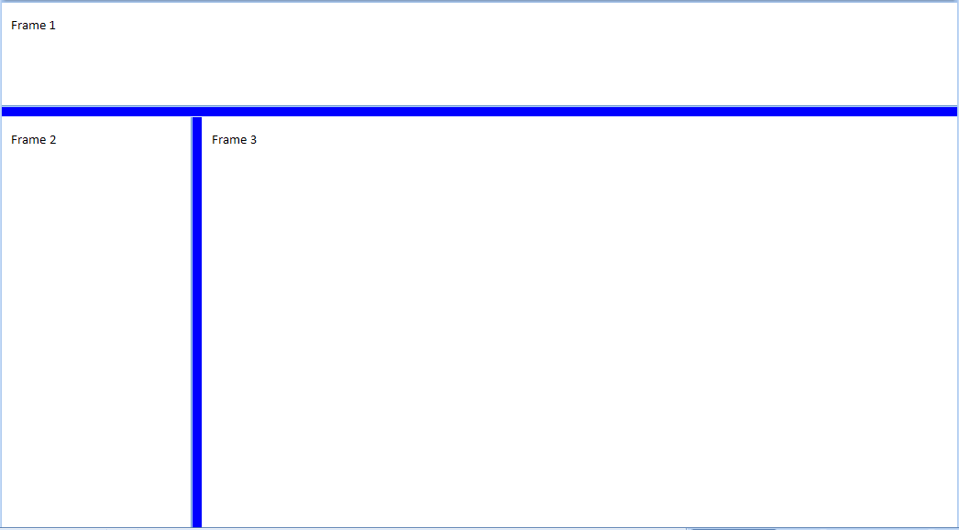

The following properties define the presentation of the top frame within this frameset:

<w:frameset>  
 …  
 <w:frame>  
 <w:sz w:val="300" />  
 <w:name w:val="Frame 1" />  
 </w:frame>  
 …  
 <w:pixelsPerInch w:val="150" />  
</w:frameset>

The sz element's val attribute specifies that the size of this frame is 300 - which translates to a height of exactly 300 pixels tall. In addition, this document specifies that the intended number of pixels per inch for this measurement is 150, resulting in a 2" tall frame height. end example]

|  |  |
| --- | --- |
| Attributes | Description |
| val (String Value) | ~~Specifies that its contents contain a string.~~  The value of the val attribute is the size for a single frame within a frameset.  ~~The contents of this string are interpreted based on the context of the parent XML element.~~  ~~[Example: Consider the following WordprocessingML fragment:~~  ~~<w:pPr>~~  ~~<w:pStyle w:val="Heading1" />~~  ~~</w:pPr>~~  ~~The value of the val attribute is the ID of the associated paragraph style's styleId.~~  ~~However, consider the following fragment:~~  ~~<w:sdtPr>~~  ~~<w:alias w:val="SDT Title Example" />~~  ~~…~~  ~~</w:sdtPr>~~  ~~In this case, the decimal number in the val attribute is the caption of the nearest ancestor structured document tag. In each case, the value is interpreted in the context of the parent element. end example]~~  The possible values for this attribute are defined by the ST_String simple type (§xx). |

…

**Part 1: §17.15.2.40 sz, “(Nested Frameset Size)”, p. xx**

This element specifies the size for a frameset that has been nested within another frameset. If this size appears on a root frameset, then it can be ignored and the main frameset shall encompass the entire window.

This size shall be interpreted based on the contents of the frameLayout element (§17.15.2.17) for the parent frameset (not the current nested frameset), as follows:

* If the val attribute on that element is cols, then this element specifies the width of the frameset
* If the val attribute on that element is rows, then this element specifies the height of the frameset

Once the axis of this measurement has been established using the criteria above, the actual value of the measurement shall be determined by the following:

* If the val attribute ends in a asterisk (*), then this measurement is a relative measurement (relative to all other frames in this frameset).
* If the val attribute ends in a percentage symbol (%), then this measurement is a percentage of the height and/or width of the parent frameset, respectively.
* Otherwise, the value of the val attribute specifies the size of the frameset in pixels. This measurement shall be interpreted in the context of the pixelsPerInch element (§17.15.2.34) to determine the width of the resulting measurement in inches.

If this element is omitted, then no information shall be implied about the size of the current frameset.

[Example: Consider a nested frameset defined as follows:

<w:frameset>  
 …  
 <w:frameset>  
 <w:sz w:val="50%" />  
 …  
 </w:frameset>  
 …  
 <w:pixelsPerInch w:val="150" />  
</w:frameset>

The sz element's val attribute specifies that the size of this nested frameset is 50% - which translates to a width of fifty percent of the width of the parent frameset's height. end example]

|  |  |
| --- | --- |
| Attributes | Description |
| val (String Value) | ~~Specifies that its contents contain a string.~~  The value of the val attribute is the size for a frameset that has been nested within another frameset.  ~~The contents of this string are interpreted based on the context of the parent XML element.~~  ~~[Example: Consider the following WordprocessingML fragment:~~  ~~<w:pPr>~~  ~~<w:pStyle w:val="Heading1" />~~  ~~</w:pPr>~~  ~~The value of the val attribute is the ID of the associated paragraph style's styleId.~~  ~~However, consider the following fragment:~~  ~~<w:sdtPr>~~  ~~<w:alias w:val="SDT Title Example" />~~  ~~…~~  ~~</w:sdtPr>~~  ~~In this case, the decimal number in the val attribute is the caption of the nearest ancestor structured document tag. In each case, the value is interpreted in the context of the parent element. end example]~~  The possible values for this attribute are defined by the ST_String simple type (§xx). |

…

Changes to Part 1: Y Part 2: N Part 3: N Part 4: N