DR 16-0018 — WML: need sort method for special characters

Status: Open

Subject: WML: need sort method for special characters

Qualifier: Technical defect

Submitter: Chunyan Fang Organization: (CESI)

Contact Information: fangcy@cesi.cn

Submitter’s Defect Number: none

Supporting Document(s): none

Date Circulated by Secretariat: 2016-09-26

Deadline for Response from Editor: 2016-11-26

IS 29500 Reference(s): 29500:2016 Part 1, §18.18.73, “ST_SortMethod (Sort Method)”, p. 2484

Related DR(s): none

Nature of the Defect:

There is no description about the sort methods for special characters

We can see following description in §18.18.73 ST_SortMethod (Sort Method):

Enumeration Value：none (None)

Description：Not specified, use default sort method.

But when cells sort by some special characters, we could not find the sort method for them.

For example:

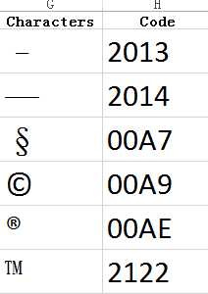

Solution Proposed by the Submitter:

Add the description about the sort methods for special characters

Schema Change(s) Needed:

No

**Editor’s Response:**

**2016-12-07 Rex Jaeschke:**

From MS experts: This DR is asking us to specify runtime, implementation-specific behavior for how sort works on special characters. We don’t believe this is in scope of the documentation.

Changes to Part 1: N Part 2: N Part 3: N Part 4: N