DR 16-0011 — WML: Style Hierarchy, Possible Contradiction

Status: Further Consideration Required

Subject: WML: Style Hierarchy, Possible Contradiction

Qualifier: Technical defect

Submitter: WG4 Organization: WG4

Contact Information: Click here to enter text.

Submitter’s Defect Number: None

Supporting Document(s): None

Date Circulated by Secretariat: 2016-04-17

Deadline for Response from Editor: 2016-06-17

IS 29500 Reference(s): 29500:2016, Part 1, §17.7.2, “Style Hierarchy” and §L.1.8.10, “Style Application”

Related DR(s): None

Nature of the Defect:

The text description below the table that illustrates the order of application of the defaults, does not match the ordering of style application shown in the table w.r.t paragraph and numbering. And the diagram in §L.1.8.10, “Style Application” puts Numbering above Paragraph. The textual description suggests that application of numbering and paragraph styles are somewhat interwoven. So, we have an inconsistency between the normative text and the informative annex.

Solution Proposed by the Submitter:

None

Schema Change(s) Needed:

No

**Editor’s Response:**

**2016-12-14 Aarti Nankani:**

From MS experts: To summarize, the original complaint is that there's a discrepancy between §17.7.2 and §L.1.8.10. The question is what is the correct ordering when applying styles for paragraphs and numbering.

I've attached ListAndParaStylesTest.docx.  I believe this document shows that paragraph styles are applied after (override) numbering styles. In other words, I believe §L.1.8.10 is correct–the picture and the text in that section are consistent and correct.

To prove this, my test document has a paragraph style I defined called "CameronParaStyle" (at the bottom of the styles.xml part).  This style applies an indent of 120 (.08") and also specifies a numbering style of "1". At the bottom of numbering.xml, you can see the number style with the id of 1 uses abstractNumId of 0. Looking at abstractNumId 0 (at the top of numbering.xml), you can see we specify an indent of 2880 (2.0").

This means we have a paragraph style and a numbering style both being applied to the first paragraph. When we view this document in Word, we see the indent for the first paragraph is .08", not 2", which shows the paragraph style overrode the numbering style.

**2016-12-19 Francis Cave:**

If I’ve understood the product team’s response correctly, this would imply that the diagram in §L.1.8.10 is correct but the diagram in §17.7.2 is incorrect. The text immediately below the diagram in §17.7.2 appears to contradict the diagram, but agree with §L.1.8.10, which is consistent with the product team’s response. So, I think this can most easily be resolved simply by replacing the diagram in §17.7.2 with a copy of the diagram in §L.1.8.10.

However, the easy approach is not necessarily the best approach. The text in §L.1.8.10 seems to duplicate almost precisely the text in §17.7.2. The only differences are that in §17.7.2 the process is represented by a bulleted list, and the final paragraph of §17.7.2 is omitted from §L.1.8.10. This highlights the main danger of this kind of repetition: that contradictions can creep in. Ideally, we should eliminate §L.1.8.10, or at least make it a simply reference §17.7.2.

**2017-01-05 Rex Jaeschke:**

Based on Francis’ analysis, here are the proposed edits:

**Part 1: §17.7.2, “Style Hierarchy”, pp. 615–616**

Replace the following figure

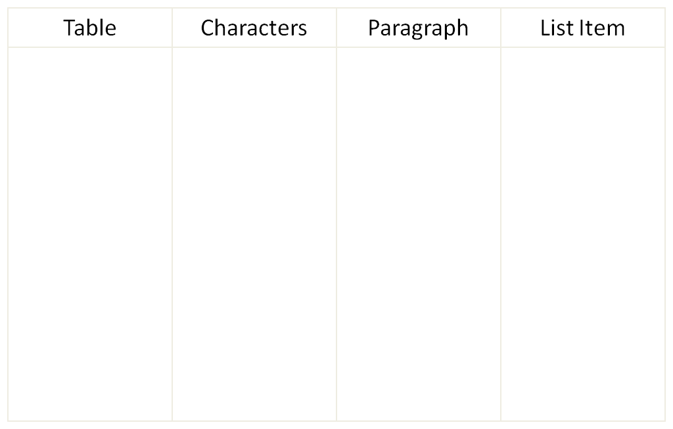

Application order

Document Defaults

Table

Paragraph

Numbering

Character

Direct Formatting

With this one:

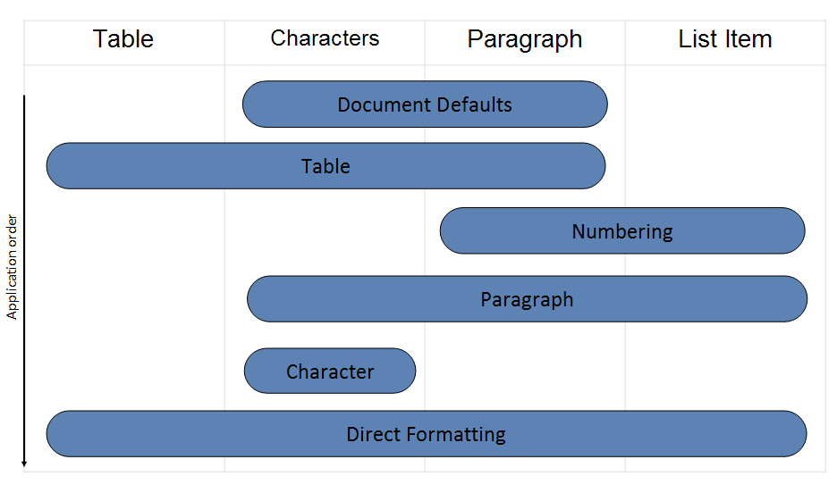

**Part 1: §L.1.8.10****, “Style Application”, p. 4579**

*{Delete this entire subclause (there are no forward references to it.}*

Changes to Part 1: Y Part 2: N Part 3: N Part 4: N