DR 17-0011 — Shared ML: Problem with ST_OnOff

Status: Open

Subject: Shared ML: Problem with ST_OnOff

Qualifier: Technical defect

Submitter: Richard ?? Organization: TC45

Contact Information: [p1@originsystems.co.za](mailto:p1@originsystems.co.za)

Submitter’s Defect Number: none

Supporting Document(s): none

Date Circulated by Secretariat: 2017-03-15

Deadline for Response from Editor: 2017-05-15

IS 29500 Reference(s): 29500:2016 Part 1, §22.9.2.7, “ST_OnOff (On/Off Value)”, p. 3790

Related DR(s): none

Nature of the Defect:

I am interested in the following 2 things:

**Bug?**

The ECMA 5th edition Part 1 strict schema does not validate in Altova XMLspy 2017, as shown here:  
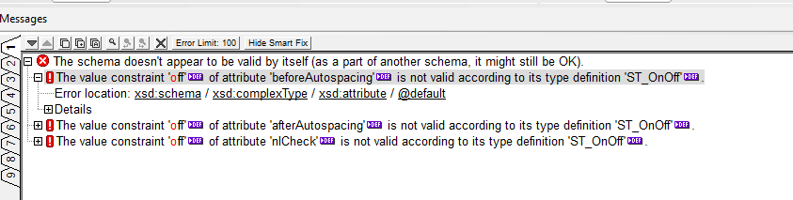  
  
I believe this is due to ST_OnOff being of type xsd:boolean as follows:

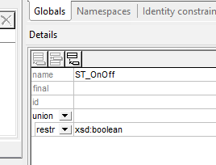

combined with a number of schema attributes of the type ST_OnOff having a default value of “off” - which does not comply with xsd:boolean; eg.,

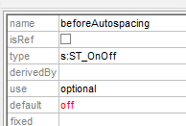

**Concern**

Because of the above issue, I have not tested against the strict ECMA schema, but Office 365 Word documents do not appear to comply to the 5th edition transitional schema. For example, validating document.xml of the attached Office 365 Word document fails validation against wml.xsd as shown here.  Is this expected?

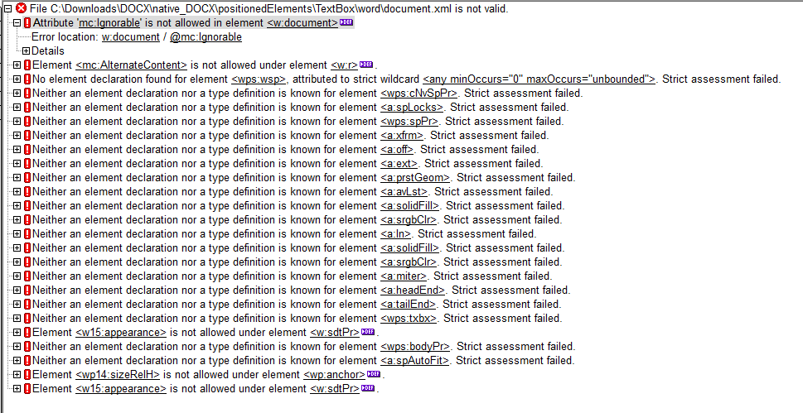

Also, I see similar problems validating both Word 2010 and 2013 documents against the Transitional wml.xsd (ECMA-376 5th version)

[In follow-on mail some days later]

I really am very keen to hear your feedback, and in particular to understand whether the observed behaviour is due to:

1. A bug in the ECMA-376 5th version schema - and if so, whether / when it will be fixed ; *or*
2. Microsoft Word not adhering to ECMA 376 standard; *or*
3. The ECMA-376 standard intentionally being created as a subset of Microsoft Word with no intention to have Microsoft fully comply

or some combination of the above.

The reason this information is so important to us is because our current strategy is to use ECMA-376 to validate Word document integrity - and as the schema currently stands we are unable to do so. Understanding the issue more clearly will allow us to select the appropriate strategy.

Solution Proposed by the Submitter:

None

Schema Change(s) Needed:

No

**Editor’s Response:**

**2017-03-15 Rex Jaeschke:**

Hi all, I’m on vacation through the end of next week, but just received this and thought I’d circulate it to a few people.

The mention of a problem with ST_OnOff reminded me of a DR we worked on in the past year or so (don’t recall which), which we might have closed AFTER the latest edition was frozen.

**2017-03-15 Francis Cave:**

I can only see DR 15-0022 – ST: No subclause for ST_OnOff1, which was resolved by introducing a new subclause in Part 4. The DR was closed in COR4.

I’ve done a search for ‘default=”off”’ in the latest edition and there are three occurrences in Appendix A.1:

* Page 3816, line 598 and line 601
* Page 3818, line 671

These are certainly defects, because s:ST_OnOff is of type xs:boolean, and the only valid values are ‘true’, ‘false’, ‘1’ and ‘0’.

I’ve only looked at the Appendix text, not the schemas.

**2017-03-20 Rex Jaeschke: (private mail to submitter)**

Hi Richard, I am on vacation, but saw your mail and forwarded it to the Ecma and ISO committees for their consideration.

Just to set some expectations, do not expect a reply any time soon. We have face-to-face meetings every 4 months, we have 2-hour teleconferences every 5–6 weeks, and we do some business by email in between. Many participants are volunteers; that is, they have a day job. Also, we have quite a few other DRs in the process queue ahead of you, and we’re busy revising Part 2 (OPC).

Note that it is not the business of Ecma TC45 nor ISO/IEC JTC 1/SC 34/WG4 to comment on specific implementations and commercial decisions. However, the MS folks have received your mails as have all other committee members.

Changes to Part 1: N Part 2: N Part 3: N Part 4: N