DR 17-0032 — After-Paragraph Spacing

Status: Open

Subject: WML: After-Paragraph Spacing

Qualifier: Request for clarification

Submitter: Richard Harding Organization: TC45

Contact Information: [p1@originsystems.co.za](mailto:p1@originsystems.co.za)

Submitter’s Defect Number: none

Supporting Document(s): none

Date Circulated by Secretariat: 2017-10-13

Deadline for Response from Editor: 2017-12-13

IS 29500 Reference(s): 29500:2016 Part 1, §17.3.1.33, “spacing (Spacing Between Lines and Above/Below Paragraph)”, p. 248

Related DR(s): none

Nature of the Defect:

I have encountered what I believe to be an anomaly - in either the spec or Word (Office 365). The spec says:

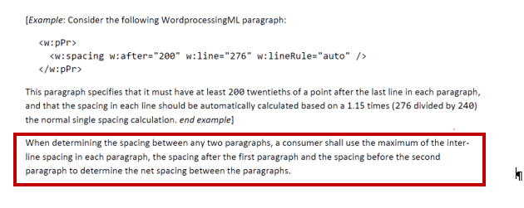

I am using Arial 10pt font in conjunction with w:spacing values of

w:line = 360  
w:lineRule = auto  
w:after=800

And the above definition is not the way it is working.  What I am seeing is that the w:line spacing value is being added to the w:after spacing. It is not taking the maximum the 2 as specified above.

I will illustrate using a visual example…

**Step 1: I create some text having no inter-line or after paragraph spaces**

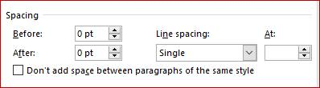

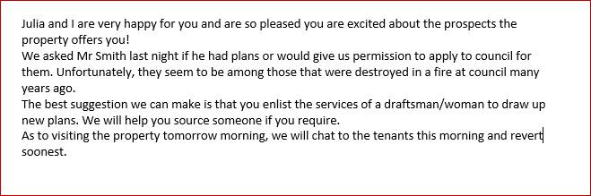

**Step 2: I introduce after-paragraph spacing of 18pt**

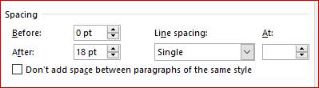

The arrow below is used to illustrate the after-paragraph space that the above change introduces.

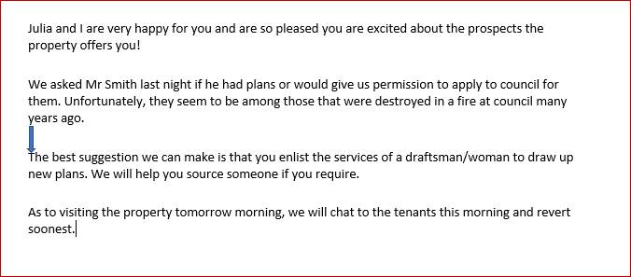

**Step 3: I introduce inter-line spacing of 1.5 lines**

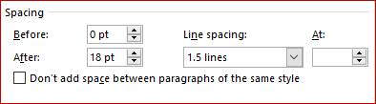

As can easily be seen below, the arrow – which remains exactly the same size as in step 2 above – now no longer fills the after-paragraph spacei.e. the actual space between paragraphs has increased due to the change to the inter-line spacing within the paragraph.

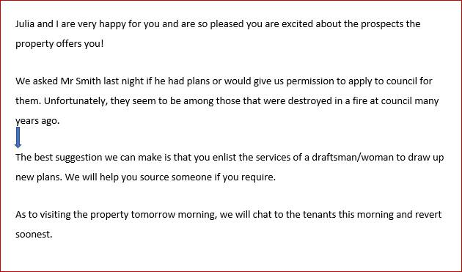

According to my understanding of the spec rule: the maximum of the inter-line and after-paragraph spaces should be used to determine the gap between paragraphs; not both of them.

From this I can only conclude there is either a problem in the spec or a bug in Word (Office 365).

Regardless of cause, the handling I’m experiencing above makes it impossible for me to logically divorce *w:line* from *w:after* ie. to reliably create paragraphs having different inter-line spaces while retaining a consistent after-paragraph space.

Solution Proposed by the Submitter:

None

Schema Change(s) Needed:

No

**Editor’s Response:**

None

Changes to Part 1: N Part 2: N Part 3: N Part 4: N