DR 17-0031 — WML: Spacing Between Paragraphs

Status: Open

Subject: WML: Spacing Between Paragraphs

Qualifier: Request for clarification

Submitter: Richard Harding Organization: TC45

Contact Information: [p1@originsystems.co.za](mailto:p1@originsystems.co.za)

Submitter’s Defect Number: none

Supporting Document(s): none

Date Circulated by Secretariat: 2017-10-13

Deadline for Response from Editor: 2017-12-13

IS 29500 Reference(s): 29500:2016 Part 1, §17.3.1.33, “spacing (Spacing Between Lines and Above/Below Paragraph)”, p. 248

Related DR(s): none

Nature of the Defect:

The rule below [in the red box] is not the behaviour I’m experiencing in Word (Office 365).

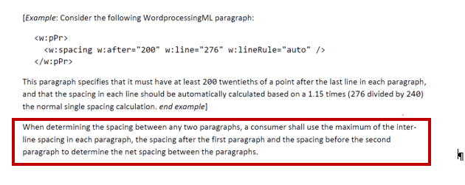

To illustrate, see the following post-paragraph gap determined for and Arial 10pt paragraph:

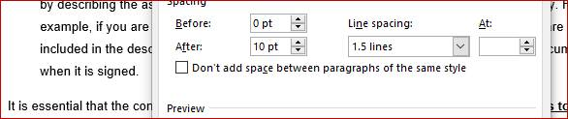

Now, as - for a font size of 10 points - the “After: 10pt” represents a larger space than the space introduced by Line spacing: 1.5 lines (which is clearly seen by comparing the height of the post-paragraph space to the gap below the other lines in the above paragraph), applying the above rule my expectation is that reducing the line spacing from 1.5 lines to “Single” would make no difference to height of the post paragraph space.

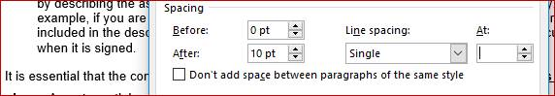

However, the post-paragraph space DOES decrease. The arrow in both images is exactly the same height, and shows clearly that changing Line spacing from *1.5 lines* to *Single* has reduced the height of the post-paragraph space.

Do you agree that this behaviour is at odds with the specification? Or am I misunderstanding something?

Solution Proposed by the Submitter:

None

Schema Change(s) Needed:

No

**Editor’s Response:**

None

Changes to Part 1: N Part 2: N Part 3: N Part 4: N